**Laboratory Procedures   
DeVry University  
College of Engineering and Information Sciences**

## OBJECTIVES

1. Get the Raspberry PI up and running and explore the desktop.

## II. PARTS LIST

The Raspberry PI components

* Raspberry PI motherboard
* Plastic case
* SD card (contains Linux operating system)
* HDMI cable (RGB or analog cables could be used as substitute)
* USB keyboard and mouse
* Micro USB power supply
* Ethernet cable or micro USB wireless adapter
* Power supply

## III. PROCEDURE (overview)

1. Assembling the Raspberry PI
   1. Place the motherboard in the case.
   2. Insert the SD card.
   3. Connect your display.
   4. Plug in a USB keyboard and mouse.
   5. Connect to your wired network (required for internet access).
   6. Plug in the micro USB power supply.
2. Starting the Raspberry PI
   1. Plug the micro USB power supply to your electrical wall source.
   2. Enter the login ID: pi.
   3. Enter the Password: raspberry.
   4. Enter startx to head to the desktop.
3. Exploring the Desktop

**IV. PROCEDURE (step by step)**

1. Assembling the Raspberry PI. You may have a B+ model so the picture may look a little different
   1. Place the motherboard in the case.

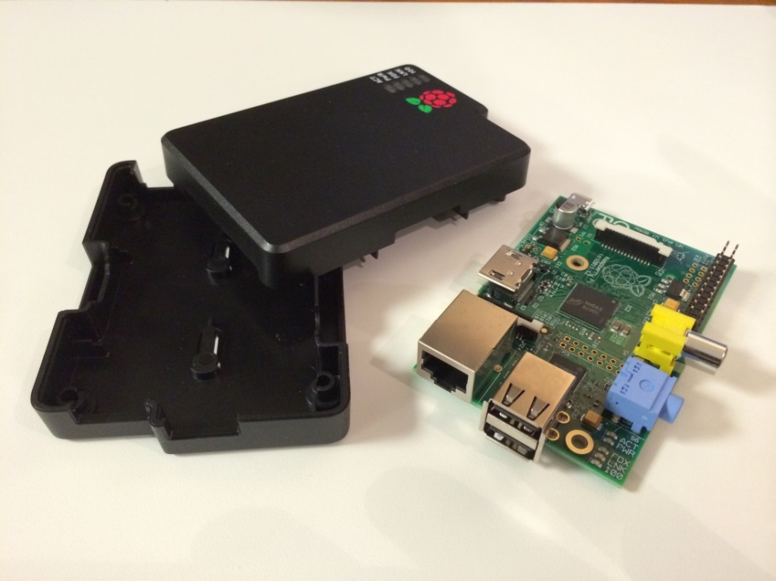

Your Raspberry PI may come with a clear case or a case like pictured above.

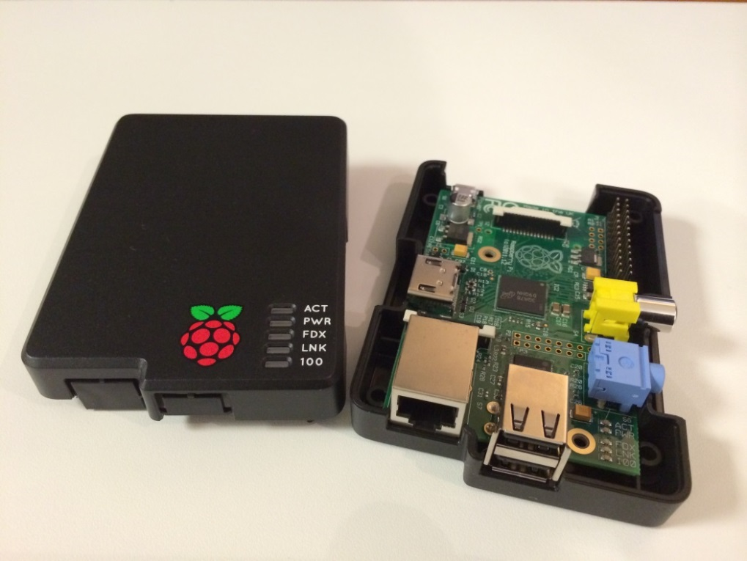

Gently insert the Raspberry PI board into the case. Once it is seated properly you may add the cover.

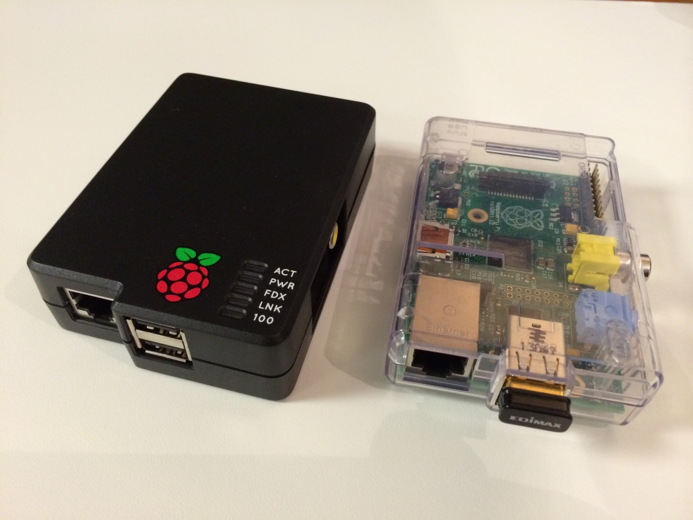

The picture above shows two Raspberry PIs. One has the black case the other is shown with a clear case. Any case is fine.

* 1. Insert the SD card.

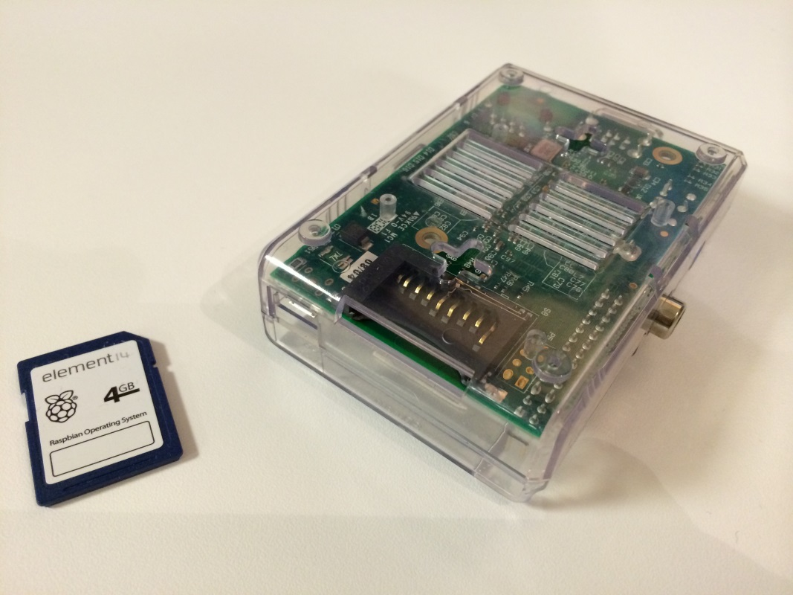

The SD card contains the operating system. In some cases when you first boot up it may ask you, “Which operating system?” If you later get that message, choose Raspian.

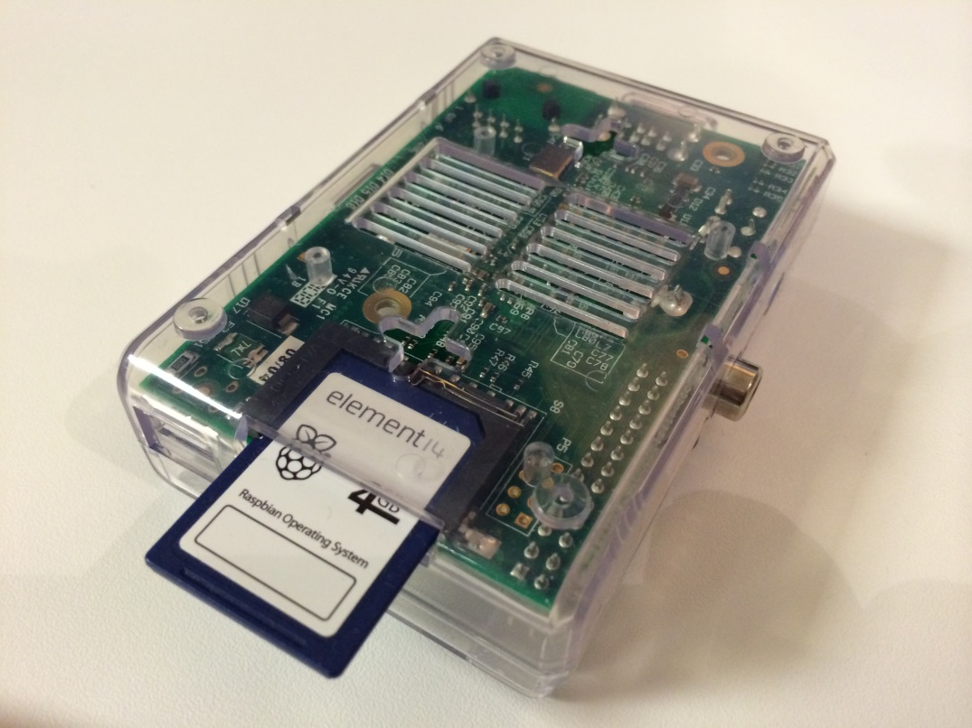

If you have a Raspberry Pi B+ model you will most likely have a micro SD card (shown on the right)

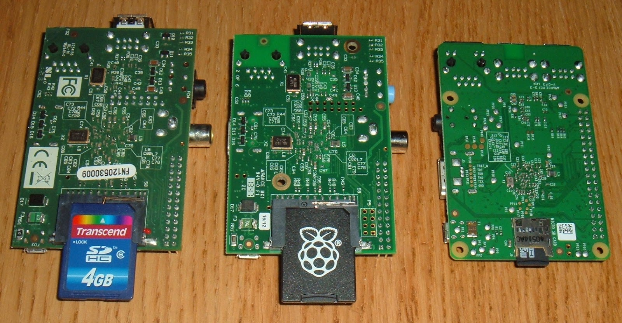

* 1. Connect your display.

You can use an HDMI cable and attach it to a television or monitor with an HDMI port…

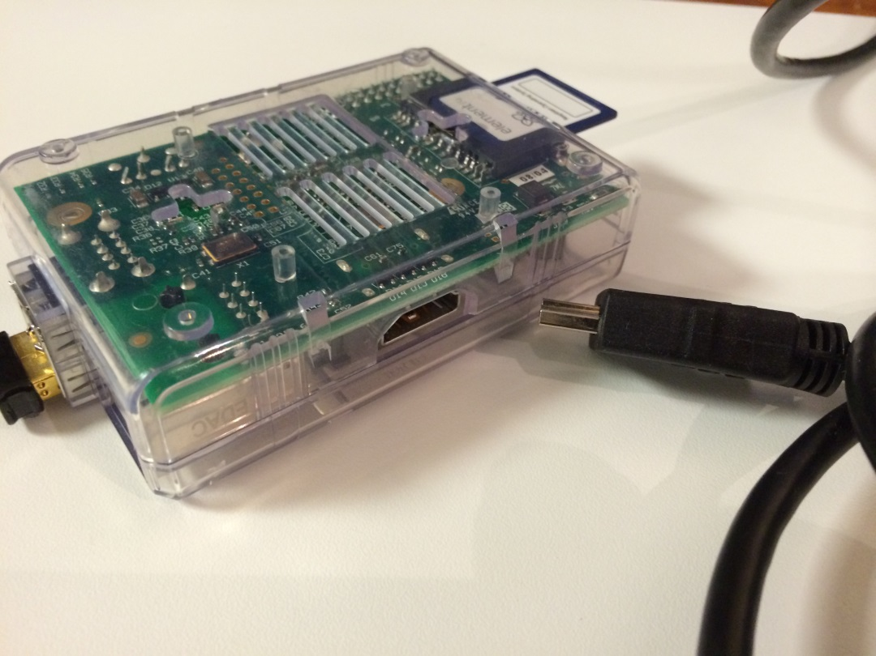

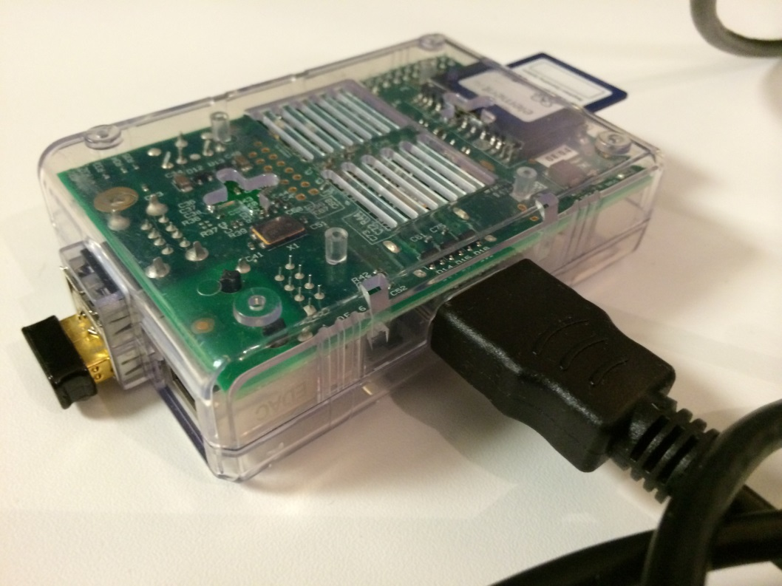

Or you can use an HDMI to RGB converter to plug it into an older-style computer monitor.

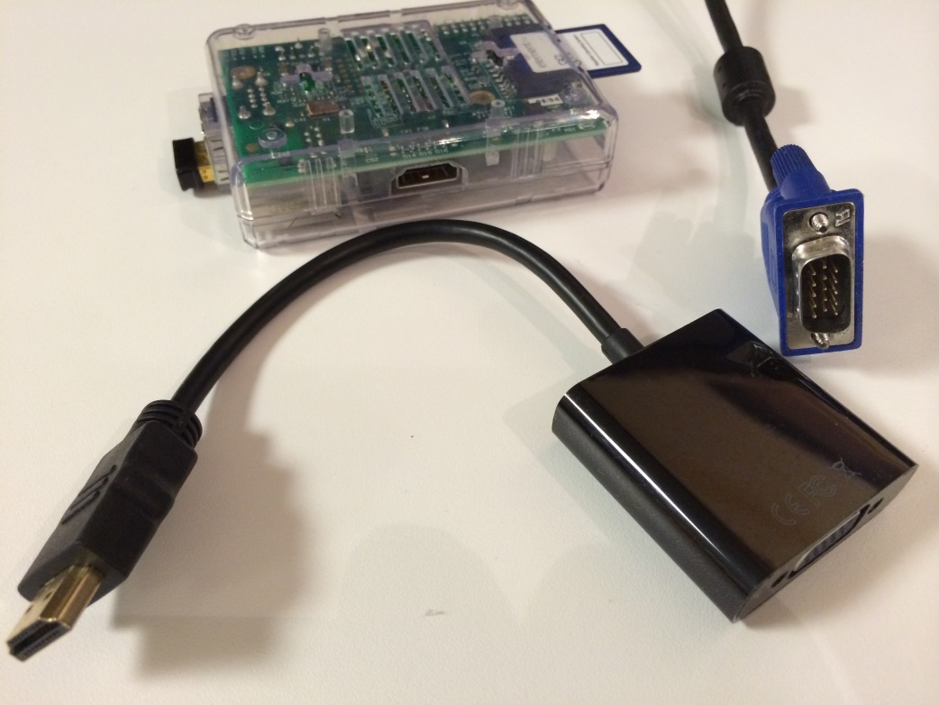

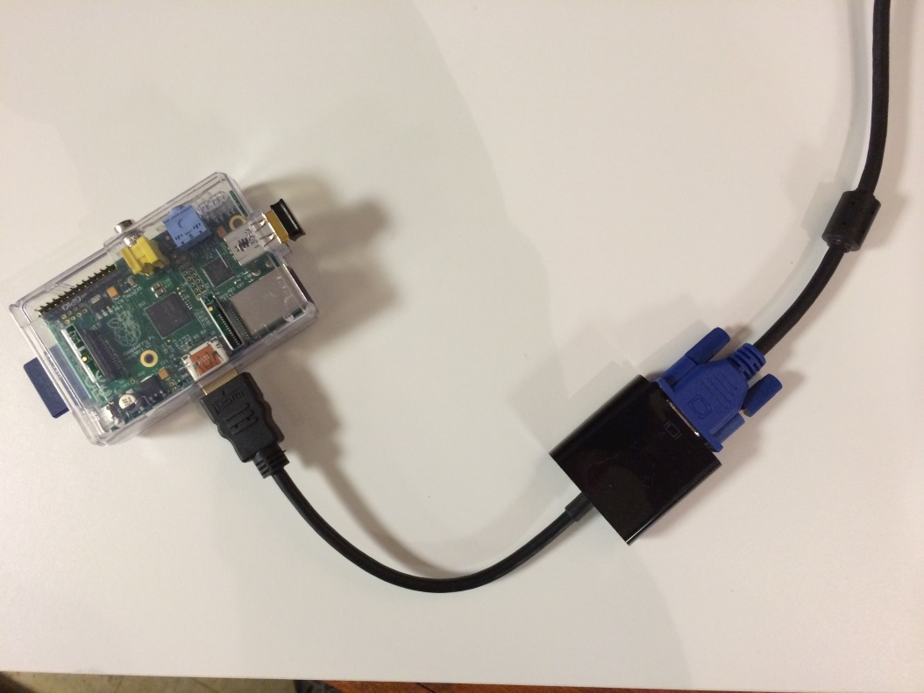

Note! Another way to hook up the device to a display is to use the analog connecter to connect directly into a television like you would with some gaming systems.

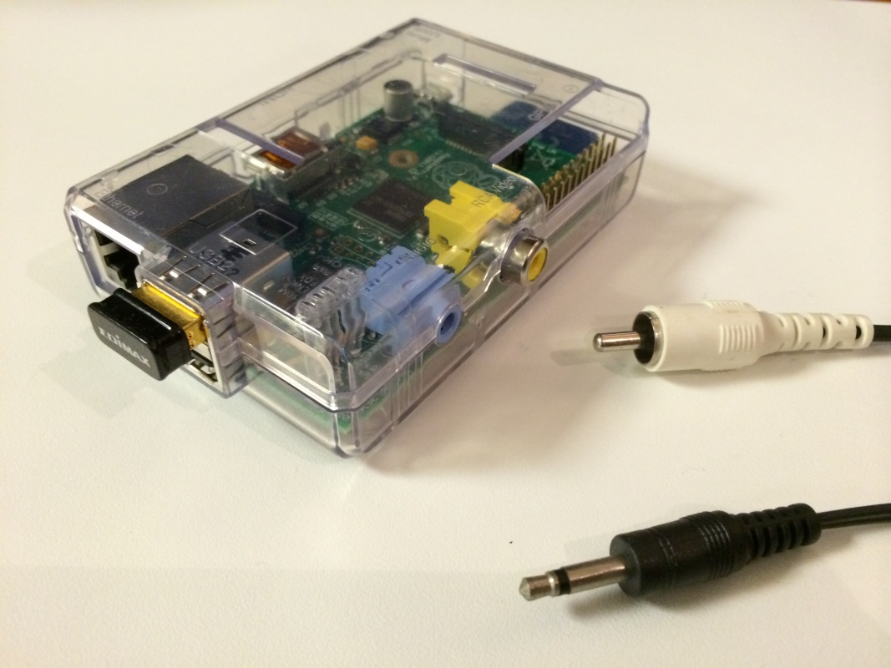

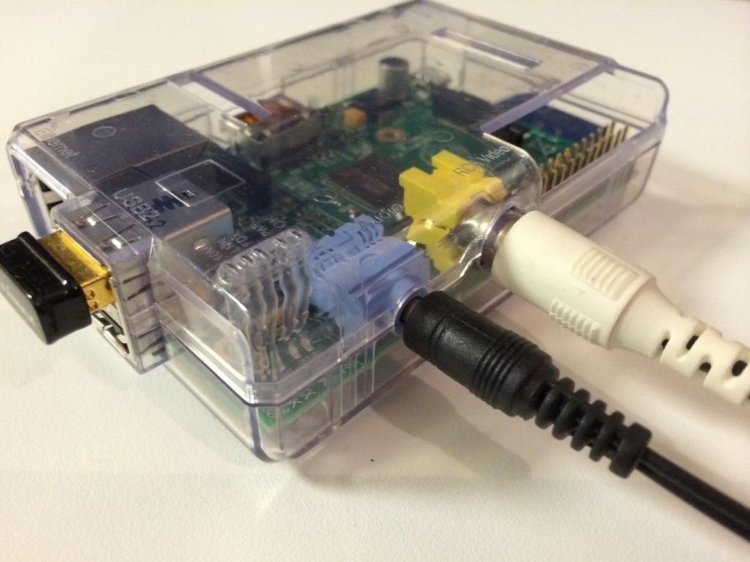

* 1. Plug in a USB keyboard and mouse.

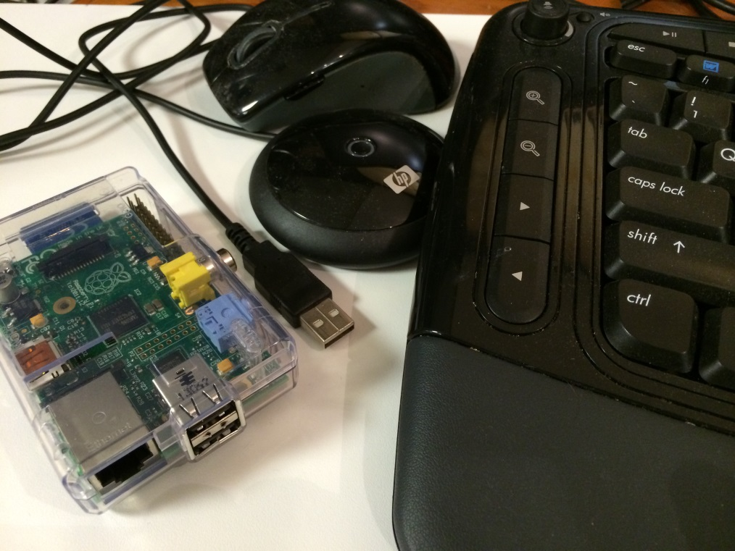

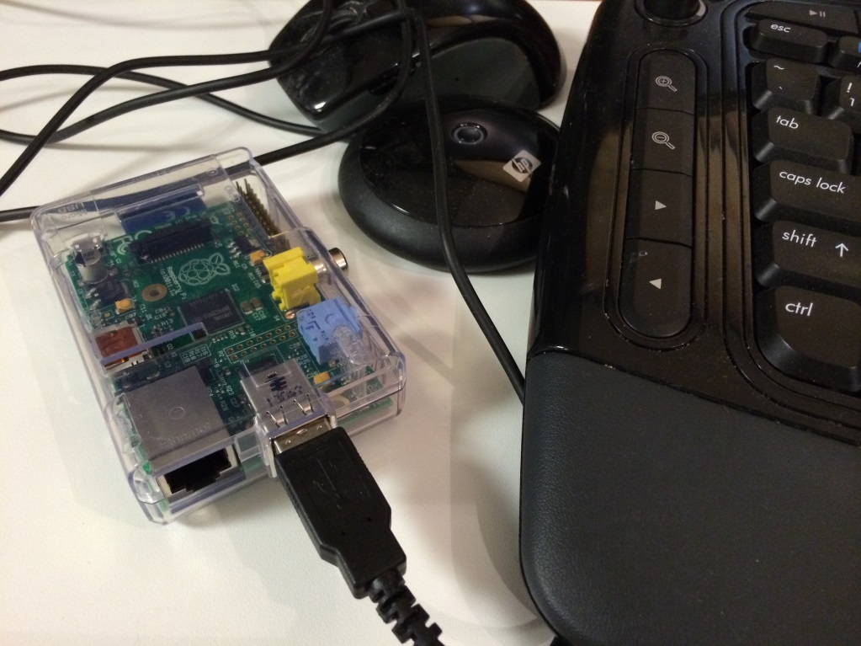

You may use a standard keyboard as shown above with its wireless USB connector or you may elect to use a small keyboard as shown below. The option is yours.

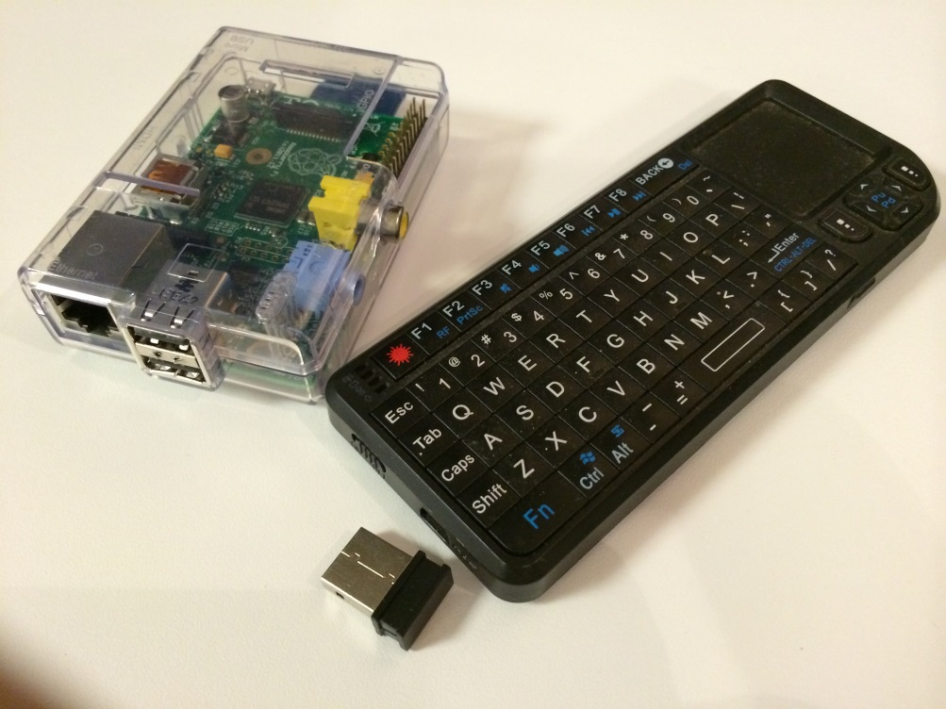

As you can see, even the small keyboard has a wireless USB connector.

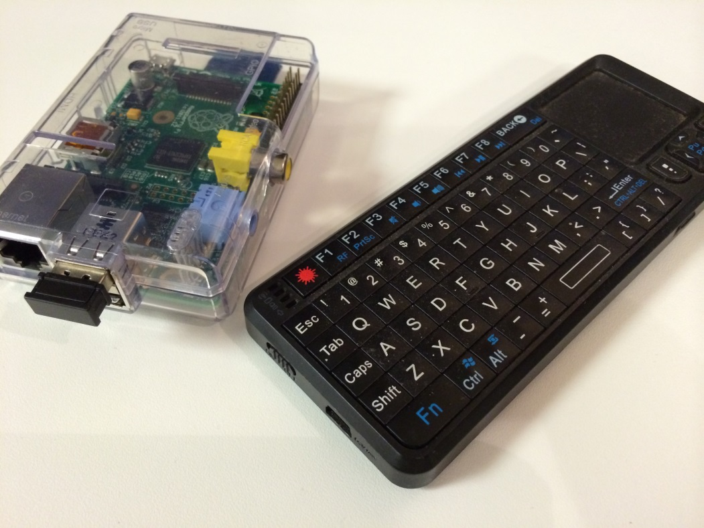

* 1. Connect to your wired network (required for Internet access).

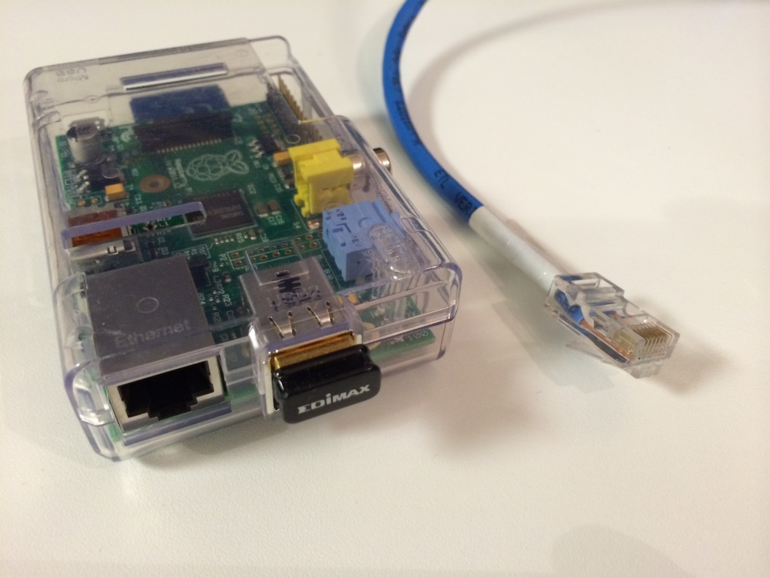

Just plug your RJ45 cable (pictured above) from your router or switch to the RJ45 port on the motherboard.

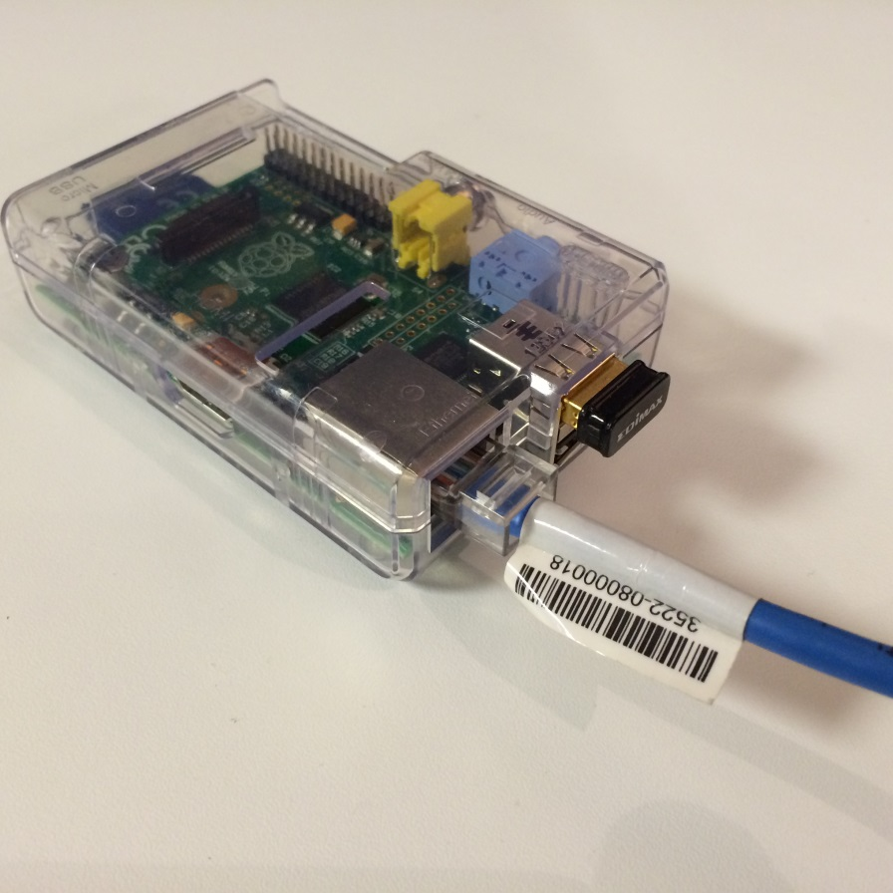

The Raspberry PI can be connected to the Internet via an RJ45 cable as show above or you can use a USB Wireless 802.11b/g/n nano adapter as shown below.

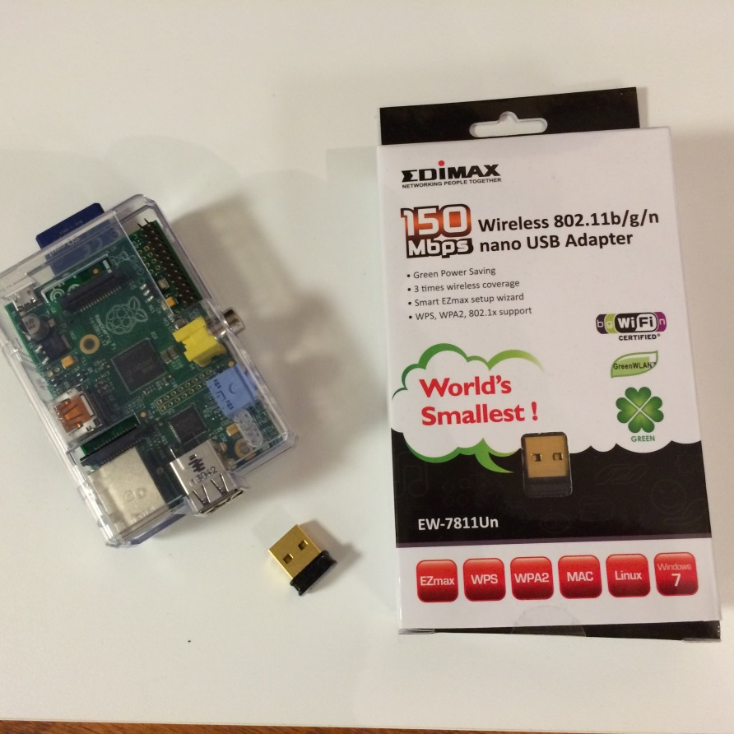

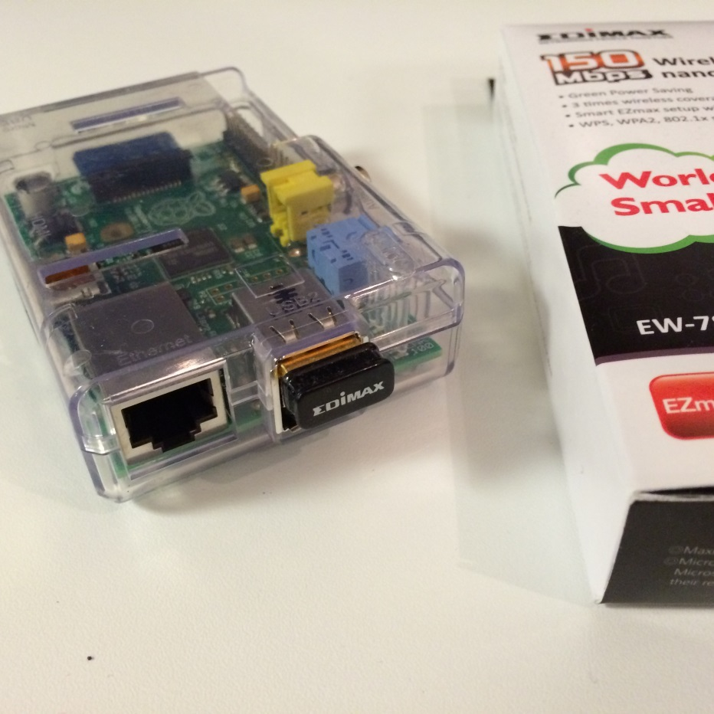

This little device gives you a lot of portability with your PI.

* 1. Plug in the micro USB power supply.

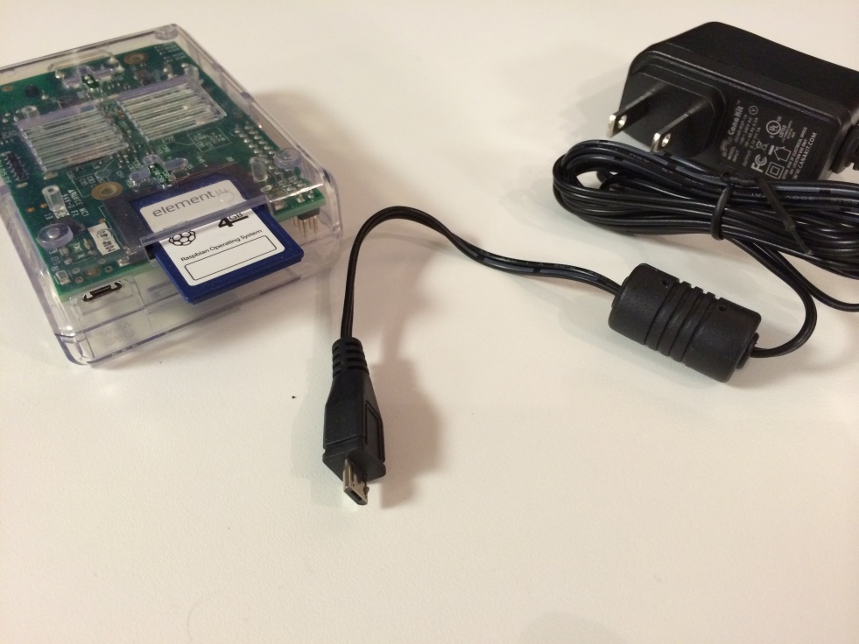

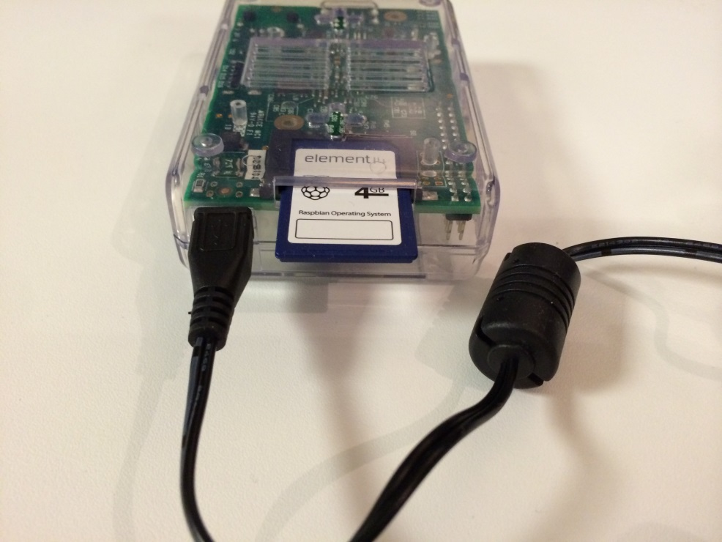

This is the last step prior to powering up. There is no on/off switch on the PI. Rather, once you plug power into the computer it turns on.

1. Starting the Raspberry PI
   1. Plug the micro USB power supply to your electrical wall source.

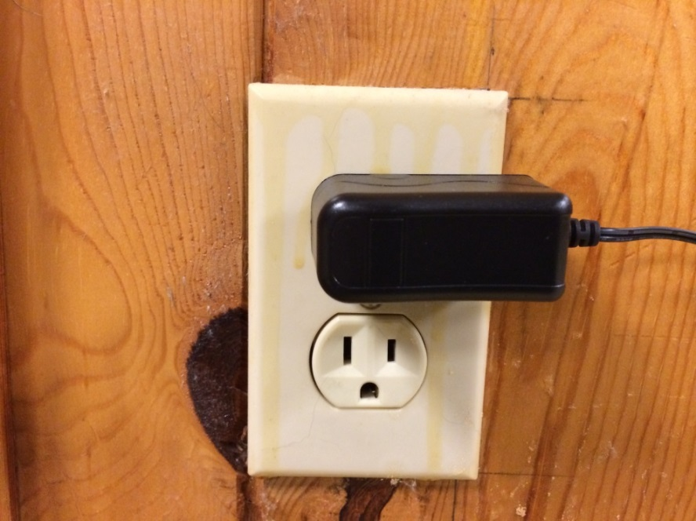

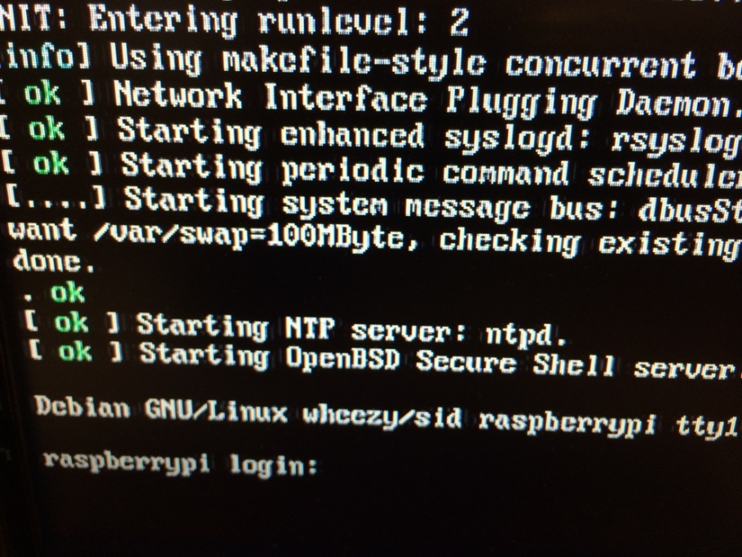

The screen will come alive. You’ll see lines and lines of system response scroll on your screen. It will finally come to a stop with a login prompt.

Note! It is possible that your Raspberry PI may start out with something different—for example, a prompt to expand your filesystem. In that case, you can simply use your tab key to move to finish and press enter. The system will continue and will actually bypass the login and password screen. You will end up on “d” below where you simply enter: startx.

* 1. Enter the login ID: pi.

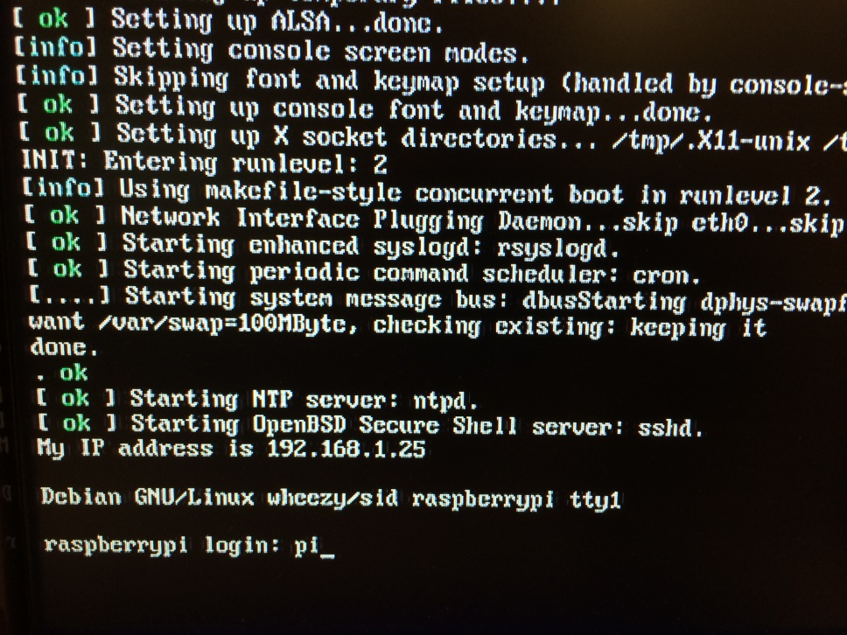

The system will respond asking for a password.

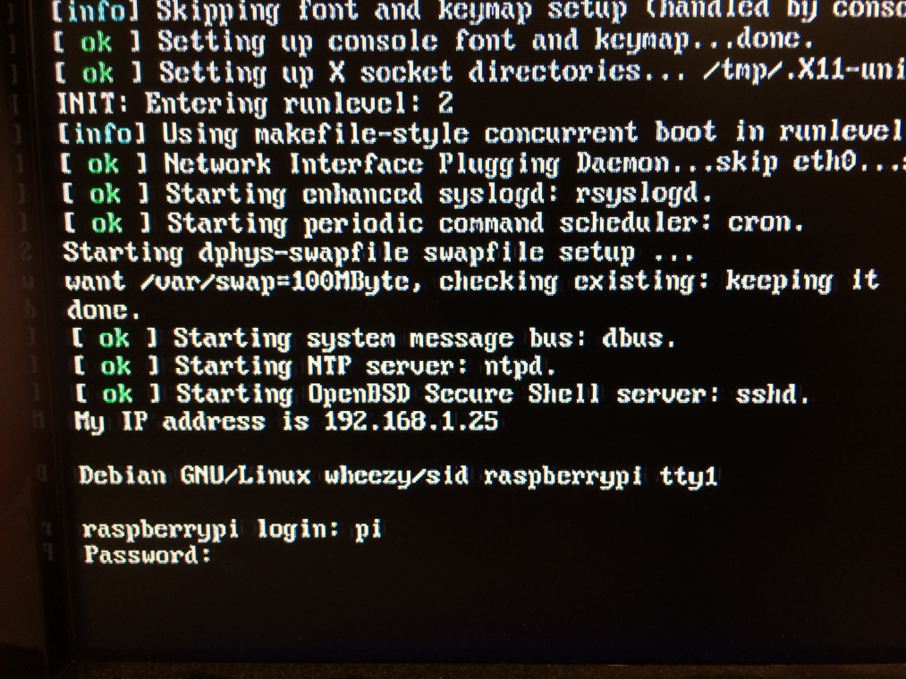

* 1. Enter the Password: raspberry.

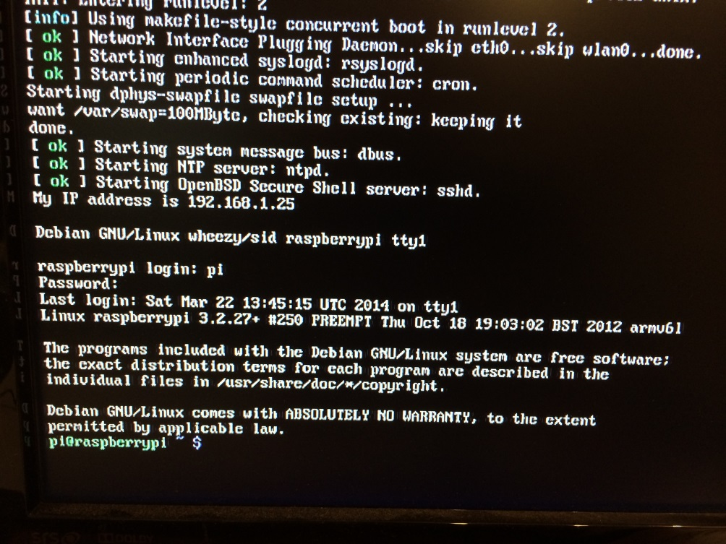

When you type the password you won’t see any letters come up on the screen. Be assured that the system is accepting your passwords. Once you press the enter key the system will return several lines of responses on your screen and rest at something we call the dollar sign prompt.

* 1. Enter startx to head to the desktop.

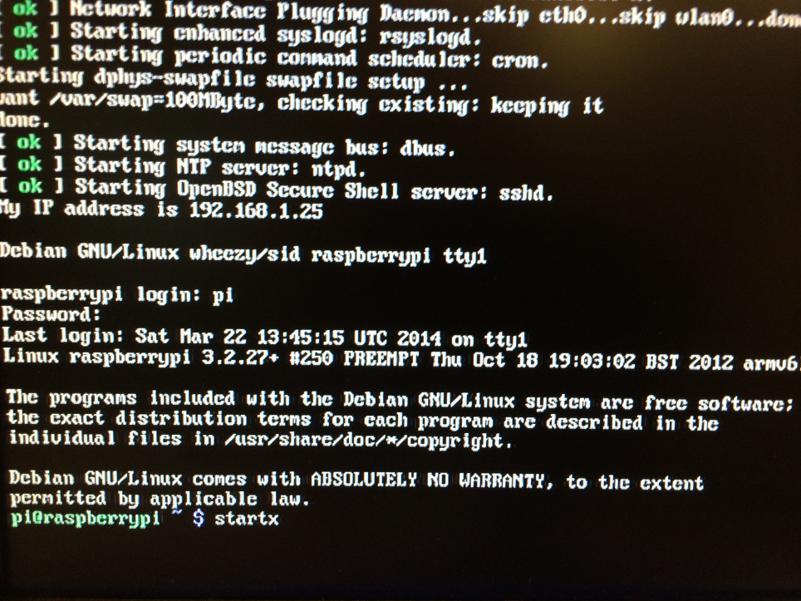

When you enter startx at the dollar sign prompt and press enter; the system will initiate the Desktop.

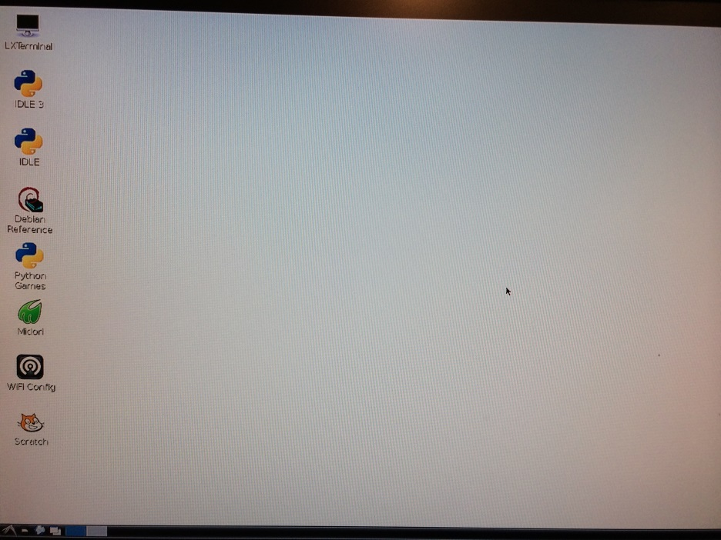

Your screen will look something like this…

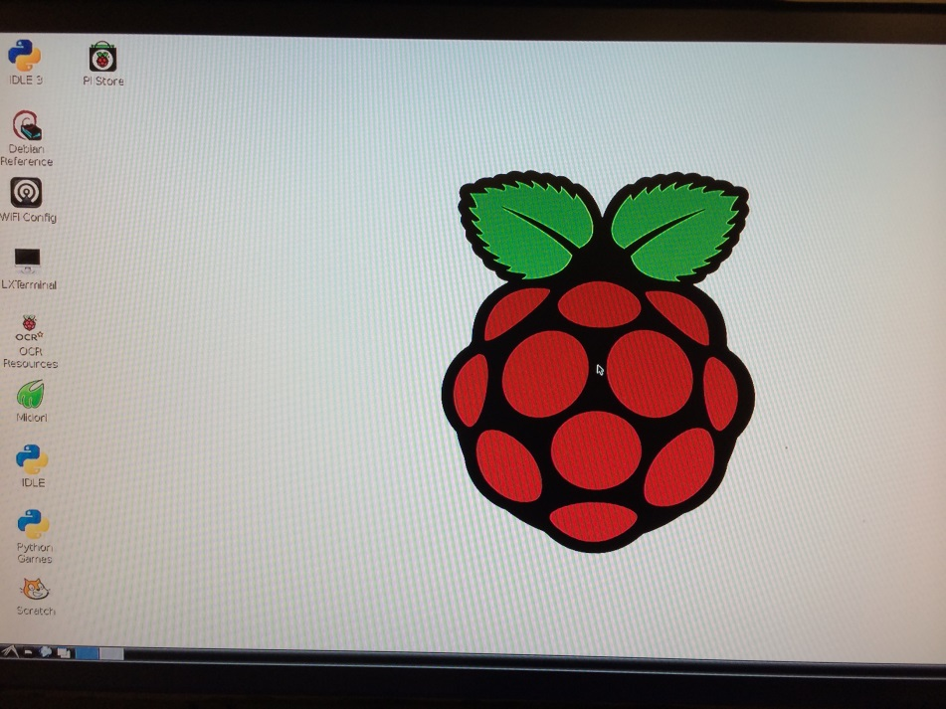

…or this

1. Exploring the Desktop
   1. Wi-Fi Config

If you have a wireless Wi-Fi USB device you can configure it here.

* 1. PI Store

After connecting to the Internet with your Raspberry PI you can explore the Raspberry PI store. Many things are available for free.

* 1. Midori

Midori is an Internet browser. Give it a try. How does it compare to IE or Google Chrome?

* 1. Others

Continue to explore other items of interest on your desktop.

1. At some point, write up your findings in your lab report.

**Laboratory Report Cover Sheet   
DeVry University  
College of Engineering and Information Sciences**

**Course Number: CEIS100**

**Professor:**

**Laboratory Number:** 4

**Laboratory Title:** Get the Raspberry PI up and running and explore the desktop.

**Submittal Date:** Click here to enter a date.

***Objectives: (What was the purpose of this lab? What did you expect to find?)***

***Results: (What did you find?)***

***Conclusions: (What does this mean? How can this be used? What implications can I draw from this?***